
Faculty of Engineering
Department of Electrical and Computer Engineering
Examination Solutions for:
Course No. and Title: | EE4212 Computer Vision
Semester/Year: | II, 2007/2008
Solution to Qn No. (& Marks): | 1 (25 marks)

- (6 marks) The edge motions (e.g., 1) are ambiguous, due to the aperture problem, whereas the corner motions (e.g., 2) are unambiguous. The T-junction motions (e.g., 3) are also unambiguous, but their motion is spurious because the corner is not a genuine physical corner.

- (4 marks)
i. The respective direction (px,py) is given by (0,1), (-1, 0), (-1/sqrt(2), 1/sqrt(2))
ii. Using the fact along these directions, there is no translational flow, we can write:
(u_rot, v_rot) (px, py) = (v_x, v_y) (px, py)
Since f=1 and there is only one rotational component; (u_rot, v_rot) = α (xy, y² + 1)
Substituting the optical flow and (x,y) into the above:
(x,y) = (1,0): (0,1) (0,1) α = (1, 0.1) (0, 1)
α = 0.1

(c) (6 marks) In a rotation around the center of projection, the center of projection does not change, and the scene of course does not change, so lines from the center of projection to the scene (the lines of sight) do not change. All the information about the cube is contained in the lines of sight. If we are given an image of a scene, we can compute what the scene looks like after such a rotation without additional knowledge from the scene, as illustrated by the figure. The sight line of a visible point in space, say P, will pass through the center of projection. The correspondent image point (the p in the first image and p’ in the second image) is the intersection point of the sight line and the image plane. If a point in space is occluded in the first image, it will still be occluded after this rotation, since the center of projection remains unchanged. This is illustrated in the figure below. This also explains why we cannot see any new facet that we do not see in the first image after this rotation.

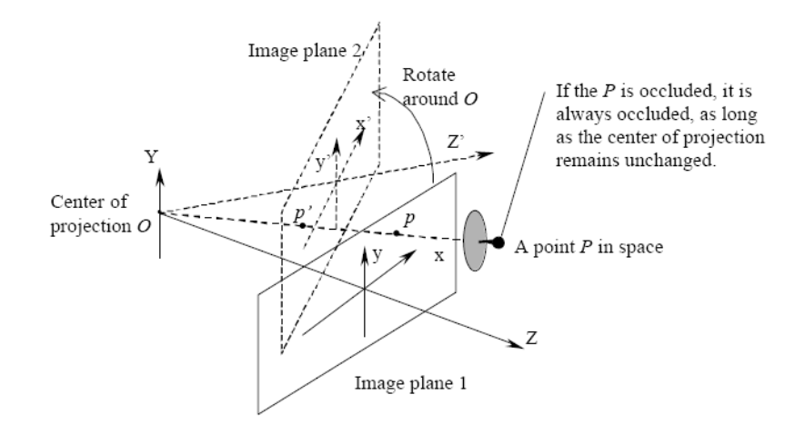

Faculty of Engineering
Department of Electrical and Computer Engineering
Examination Solutions for:
Course No. and Title: | EE4212 Computer Vision
Semester/Year: | II, 2007/2008
Solution to Qn No. (& Marks): | 1 (25 marks)

(d) (9 marks)
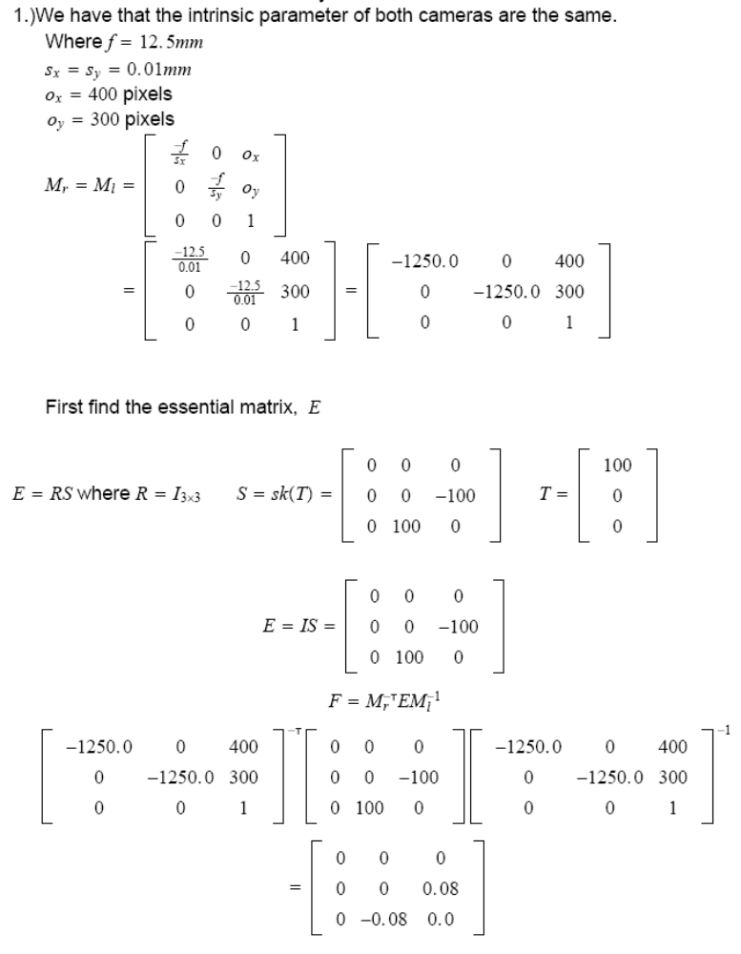
Faculty of Engineering
Department of Electrical and Computer Engineering
Examination Solutions for:
Course No. and Title: | EE4212 Computer Vision
Semester/Year: | II, 2007/2008
Solution to Qn No. (& Marks): | 2 (25 marks)

(a) (2 marks) a=-6, b=-8, c= 6, d=0

(b) (6 marks) Line at infinity = (0,0,1) since (0,0,1)^{T} (x₁,x₂,0) = 0.
Line through (a, 0, 1) and (0, b, 1) is given by their cross product: (-b,-a, ab).
Intersection of the 2 lines (-b,-a, ab) and (0,0,1) is given by their cross product: (-a,b,0)

(c) (2 marks) When the 3D line is parallel to the image plane.

- (7 marks)
No, the cameras might be facing outward (ie not converging, but diverging) (2 marks)
Rank of F = 2. Impose rank constraint by SVD, set last σ =0. (5 marks)

(e) (8 marks)
M = (a,0,b),(0,c,d),(0,0,1)). By substituting x′ = x/w, y′ = y/w, we can easily verify its correctness. (M: 4 marks; detailed mapping from R2 ←→ P2: 4 marks)

